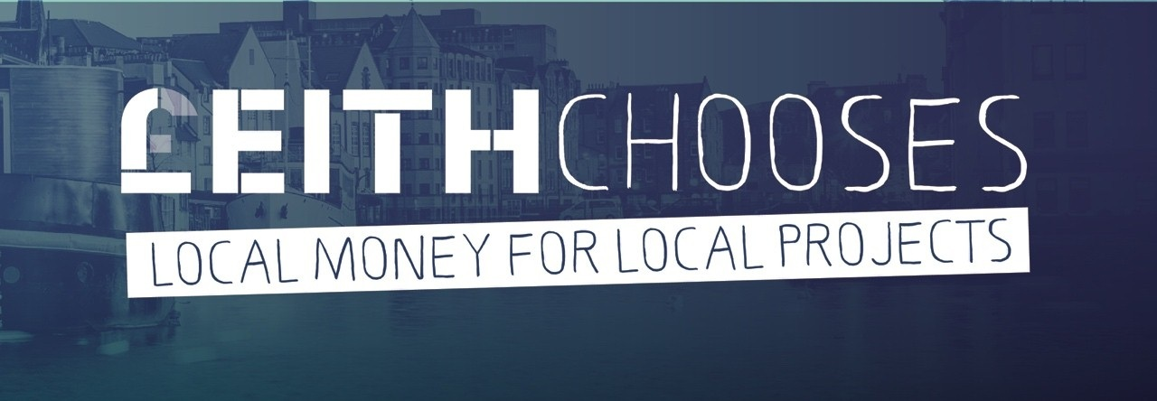
GUIDANCE NOTES

2024 – 2025

FOR COMMUNITY PROJECTS UP TO £5,000
   | What is £eith Chooses?  £eith Chooses gives the people of Leith a unique opportunity to choose, by vote, which local projects should receive funding.  Everybody who lives, works, volunteers or studies in Leith, and is over 8 years old, can vote. We want as many people as possible to take part.  Voting will take place in January 2025. There will be both ‘in-person’ voting and online voting, like last year.  Anybody who needs help to apply and/or to vote is welcome to contact the £eith Chooses team for support.
£££££££££ | Currently, approximately £44,000 is available for projects. This is from the City of Edinburgh Council Community Grants fund for Leith. Any further funds raised throughout the year will be added to this same ‘pot’ to extend the number of grants that can be made to community groups.
 | What are the timescales?  - 16 August 2024 – £eith Chooses opens for applications  - 10 October 2024: applications must be completed and submitted.  - January 2025: Voting (exact dates and details to be confirmed).  - By 31 March 2025: all funds will be disbursed to project groups.
 | Who can apply for money?  Any group or partnership can apply as long as the rules (see below) are met.  Groups can partner with another group or groups, with one group taking a ‘lead’ role in the application and assuming overall responsibility.
   | How much can you apply for?  Groups or partnerships can apply for a grant of any size up to a maximum of £5,000.  All applications are welcome!  Each group or partnership can only submit one application for funding.
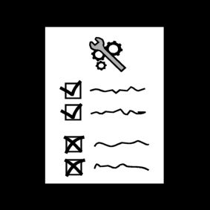 | The rules  To qualify for a grant, you must be a constituted group. In other words, you must show that your group, or the lead group in a partnership:  - has its own bank account with two signatories for cheques  - has its own constitution.  Please send in details of these along with your application.  Unconstituted groups cannot apply to this fund/ cannot be a lead applicant, as it is governed by Edinburgh Council’s rules on the use of public money.  (If further funds were to become available for small projects by unconstituted groups, this would be advertised separately.)
 | What types of projects will be funded?  - Your project must benefit the community and the people in Leith.  - Your project must address real needs in the community, and should reference evidence of these.  - Your project must either be a new project or a distinct addition to an existing project, not just a continuation of an existing / ongoing project.  - If your project is awarded £eith Chooses funding, it must be completed within 12 months from the receipt of funding, that is by 31 March 2026.
 | Is there a theme, this year? Will there be a Boost Vote again?  Yes, your project must fit within the theme: ‘Leith Uniting’  Yes, there will be a Boost Vote option again for minority ethnic community projects.
   | What kind of things will NOT be funded?  Applications will not be considered for:  - organisations/groups/projects that do not comply with equalities duties (See the Equalities Act 2010 and the Equality Act 2010 (Specific Duties) (Scotland) Regulations 2012.)  - party political, lobbying or religious activity, although applications can be accepted from faith groups if they are for local community work.  - routine property maintenance or repairs, or ongoing running costs, e.g. salaries, electricity, rent/rates, insurance, postage, phone, website.  - servicing of debt or monies already spent.  - contributions to much large fund-raising, e.g. for a new building.  - applications from bodies that are publicly funded, e.g. schools, NHS, Police. Exceptionally, community partnership projects may be considered.
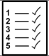 | Any other rules?  Applying  - You must submit your project outline, logo and photograph by the deadline.  - You must send a good quality photo that illustrates your group and/or your project with your application, along with permission for this to be displayed online. You must also agree that your text describing your project, will be displayed online for people to consider before and at the time of voting.  - If your project or organisation has a logo, please send this with the application and photo.  - If your project involves public or private property, you must show evidence that the owner supports your project, and that appropriate planning permission or licences are in place.  - If relevant to your project, you may also need insurance or Disclosure Scotland PVG checks.  - If your project will cost more than the amount you are applying for, you must show that you will have the rest of the money, and can complete the project.  Taking part and collecting votes  - In order to receive votes, your group MUST attend and participate in the in-person voting day event.
    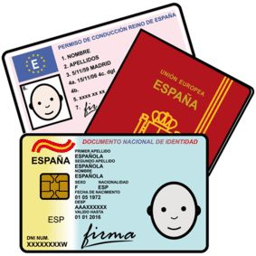 | How to apply?  Application forms can be downloaded from www.leithchooses.net or obtained by emailing leithchooses@edinburgh.gov.uk.  Fill out the application form and submit it by Tuesday 10 October 2024 at the latest. This date gives time for any necessary cross-checking and final adjustments.  You must also enclose:  - a copy of your group’s constitution  - details of your group’s bank account (bank sort code, account name, account number)  - quotes for any single items to be bought that cost £300 or more  - a good quality image: your group’s logo, a relevant photo or however you wish your project to be represented visually. This must be in JPG or PNG digital format, not on paper, emailed to leithchooses@edinburgh.gov.uk.  Your application will be checked and, if needed, you may be asked for a bit more information.
   | Can you get help with your application? How can we support you?  Yes! We really want your application to succeed and are very happy to help you. If you need any help with the application, please contact £eith Chooses as soon as possible, and we will do our very best to help you.  You can contact us directly with questions, or just for advice. You can ask for someone to speak with you and/or your group by phone, email, on a face to face visit, or by video conference etc. - about the theme and your project ideas. You can ask for a named £eith Chooses ‘mentor’ who will guide you through the whole process. You can come along to group support sessions that may be offered (to be advertised in due course).  The main thing is ‘Don’t leave this until the last minute!’ Get in touch with a request for support as soon as you are clear that you wish to apply.  Email: leithchooses@edinburgh.gov.uk  Tel: 07743 167 340
  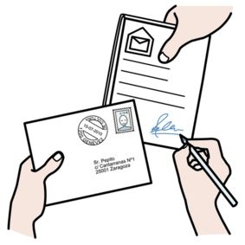 | How do you submit your application?  Print it out, get it signed, and post the paper copy, along with copies of key documents such as your Constitution, bank account details etc.  If you choose to email your application, please note that the form needs signatures, so you’ll need to arrange for a recognised, legally binding electronic signature, or follow up with a mailed signed hard copy.  Send your application to:  Tremaine Bilham,  City of Edinburgh Council  Waverley Court  4 East Market Street  Edinburgh  EH8 8BG  Email: leithchooses@edinburgh.gov.uk

 | What happens next?  - You may be contacted about details of your application that need adjustment.  - If your application meets the conditions and is accepted, you will be informed.  - Information about your proposed project will be published online, for the Leith Community to read about, via the £eith Chooses website, and later on the City of Edinburgh Council Consultation Hub.  - You are required to attend the voting day event on a Saturday in January 2025, in Leith, where you will run a stall/table and explain your project to people who come to cast their votes in person. Please note that if you do not attend, your group is at risk of being disqualified. (In case of last-minute unavoidable emergency, please be sure to contact £eith Chooses.)  - People from Leith will also cast votes online. Online voting will be open for a period of two weeks.  - Total vote numbers will be used to decide which projects will get money.  - The results will be announced publicly about 2 weeks later.
 | If the Leith people vote to give money to your project  - You will be sent a ‘letter of offer’ that will ask you to complete a simple funding agreement and acceptance form.  - When you send back those documents, the money will be put directly into your group’s designated bank account.
 | Do groups need to report on their project?  Yes, you need to send us a short report within 12 months of the start of the project, that is, by 31 March 2026 at the latest. We will send you a report template at the time funding is transferred initially, and we will also remind you around the 6 month and the 9 month stages, if necessary. You will be asked to provide:  - a breakdown of how the money was spent, together with receipts  - a short report including photos if possible showing, for example, who benefited, and how the project addressed inequalities.  We try to keep this process as short and easy as possible for you, but it is very important that this report is submitted. If it is not, your group will not be eligible to apply for funding in the future.
 | Who do we contact if we need more guidance?  Email: leithchooses@edinburgh.gov.uk  Tel: 07743 167 340
     | Online  Keep checking the £eithChooses website: www.leithchooses.net  Facebook: facebook.com/LeithChooses  Twitter: @LeithChooses

