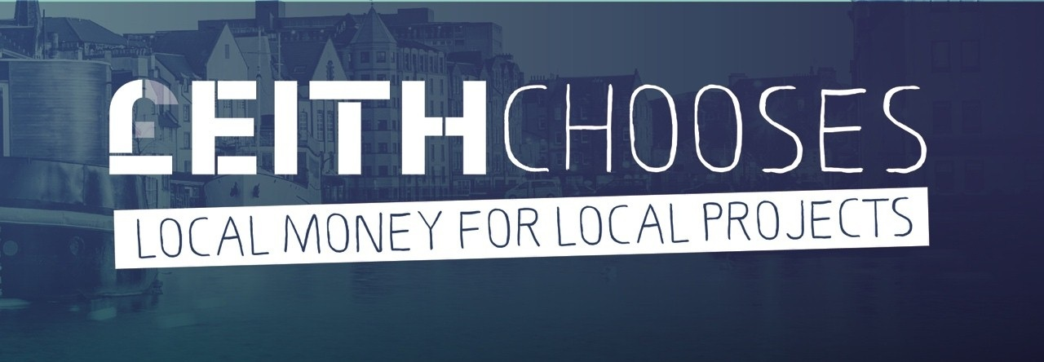
APPLICATION FORM

2022 – 2023

FOR COMMUNITY PROJECTS UP TO £5,000

Privacy notice
Your organisation’s name, main contact person and website details will be made available to the public.
We will keep other personal information that you give us confidentially.
We will only use it for the £eithChooses 2022-2023 participatory budgeting initiative.
We will not pass it on to anyone.
Any information that you give us will be stored for 2 years and then destroyed. Thank you.
Please return your form by the end of 30 September 2022 – email it to caroline.lamond@edinburgh.gov.uk
Ref no. (Office Use Only) ________________

We need the following information to consider your application
Organisation name:
Contact address and postcode:

Main contact name & position:
Telephone number: | Website address:
Email address:
Please summarise your organisation’s main aims and activities (maximum 50 words):

Addressing inequalities – your project
£eithChooses invites bids for funding for local community projects, using funding from the City of Edinburgh Council’s Community Grants Fund and the Port of Leith Housing Association. This is for small, one-off projects that meet urgent needs and progress local priorities. Your project must fit with the following theme:
Sustaining Leith
supporting and protecting the most vulnerable in our community
On the next page, please outline your project in 150 words at most. Tell us how your project matches the theme, what activities will take place, how the grant money will be spent, and what the expected outcomes are. Please say who will benefit from your project.

Please note that the information about your project that we present online for voters to read will be closely based on what you write here. Remember that how clear your project description is will affect how well voters understand your project, and whether or not they vote for it.

Project outline (150 words):

Where will your proposed project be based?

What postcodes are covered by your proposed project?

Projects must be completed within 12 months of receiving funds, i.e. by March 2024. Please state your proposed start and finish dates:

Start date ___________________________ Finish date___________________________

Equality and diversity
How many people (roughly) from the Leith area will benefit from your proposal altogether?

What proportion of these (approximately) will be from minority communities*?

What minority communities* will you include and how will your project help to meet their needs?
(* for example: ethnic and BAME minorities; people with disabilities; faith communities; older people; lesbian, gay, bisexual or transgender (LGBTQ+) people)

What proactive efforts will you make to target / involve / benefit people from minority communities?

Boost Vote
If you are working particularly with ethnic minority communities, are you applying for a Boost Vote? (See pages 5-7 for information on the qualifying criteria). Please bear in mind that £eithChooses will make the final decision on whether or not the project qualifies for a boost vote.

yes no not sure – more information needed

Partnership working
Have you consulted colleagues and/or other partners in relation to your proposal? If so, who?

Are other organisations involved in your proposal? If so, which?

Have you obtained consents, permissions or insurance necessary to carry out your proposal? (We may ask you to provide evidence of this.)

yes no not yet not necessary

Constitution and accounts
Does your organisation have a constitution? (Please note that only constituted organisations, or groups under the banner of a constituted organisation, may apply for £eithChooses 2022–2023 funds.)

yes no
Please enclose the following documents with this application:
- Constitution, or Memorandum and Articles of Association, Trust Deeds of your organisation
- Most recent annual (audited) accounts. Where your organisation is newly constituted, the most recent bank statement will suffice.
- Quotations (for any piece of equipment or machinery, or for services costing over £300)
- Evidence related to Boost Vote criteria (if relevant)

Bank account
Please give the details of the bank account this grant would be paid into if successful. This should be the same as your organisation’s name.
Name of bank
Bank address
Account name
Bank sort code
Account number

If you have any problems completing this form, please contact Caroline Lamond:
Phone 07712 538960
Email: caroline.lamond@edinburgh.gov.uk

Project financial information

Project costs
Please list each item of expenditure for this project, showing how calculated, and enclose estimates or other evidence of costs, including in kind.
If there is a specific element(s) of this you are requesting from £eithChooses, please state this clearly.
Total expenditure

Project income
If your project costs more than requested from us, please list the source of any match funding or in-kind funding for this project, or if income from charges is anticipated. Please show evidence that such funding is secured and that you can complete the project.
Total income from other sources
Amount requested from £eithChooses

Declaration
Your application must be signed by two representatives entitled to enter in agreements and receive funds on behalf of your organisation. By signing this form, you and your organisation declare that:
- You have read and will comply with all funding conditions;
- To the best of your knowledge, that the information contained in this application and any accompanying attachments is accurate.
Signature  Name  Date  Position | Signature  Name  Date  Position
Please email this completed form by 30 September 2022 to:  Caroline Lamond  email caroline.lamond@edinburgh.gov.uk | Remember to include/send  a copy of your organisation’s constitution  details of your organisation’s bank account  quotes for any items to be bought that cost £300 or more  a good quality digital image of your organisation’s logo,  a relevant photo or however you wish your project to be represented visually.

Voting Information 2022 - 2023
- Voting will be online only
- All voters get 4 votes.
- 3 votes will be cast for 3 different favourite projects – only one vote per project – out of the total number of project applications.
- The 4th vote (which is optional) is known as the ‘Boost vote’. Having already cast their first three votes, all voters can choose to cast an extra vote to support a minority ethnic project (as defined overleaf). This can be a second vote for a project they’ve already voted for, or it can be a new, extra vote for a different project.

Boost Vote 2022-2023

What is the boost vote?
In recognition of the fact that in the past minority ethnic communities and projects tended to miss out on funding, due to their minority status, the boost vote (first introduced in 2018-2019) is designed to promote fairness, as illustrated below.
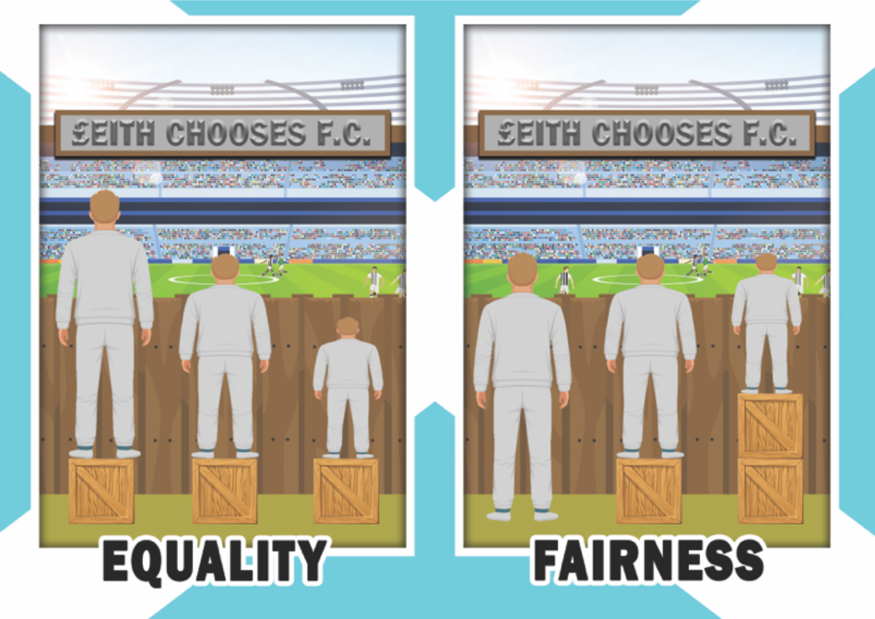
Illustration by Ash Pryce, based on an original idea by Craig Froehle (hat-tip to IISC and Angus Maguire)
All applicants should be aware of this boost vote, how it works, and how projects may qualify. Applicants should indicate if they think their project qualifies, and if they are applying for boost vote status.

Qualifying for boost votes
To qualify for boost votes, project applications must meet criteria 1 or 2 on the ‘Eligibility criteria for boost vote’ table on page 7. Organisations should first ‘self-assess’ where their project fits on this table, and tick Yes on the application form if they think they qualify. This will then be reviewed by £eithChooses organisers. Supporting evidence to demonstrate where the project fits on the table should be available. Organisations should bear in mind that £eithChooses will make the final decision on whether or not the project qualifies for a boost vote.

What is a ‘Minority ethnic project’?
Minority ethnic projects are those specifically concerned with groups or individual members of the Leith community with a different or additional original race, nationality, culture or language from the majority. There should be a clear understanding on all sides that working with people from minority ethnic communities should be a foundational (and ideally, a long-standing) part of the organisation’s work, and a key part of the proposed project, rather than just creation of a new/temporary partnership as a quick ‘tweak’ to meet short-term project funding requirements.

Eligibility criteria for boost vote
To be considered as a ‘minority ethnic project’, applying organisations must demonstrate that:

ELIGIBLE FOR BOOST VOTE
- The applying organisation specifically supports in particular one or more minority ethnic communities, and so does the proposed project.
Also:
- Management, staff and volunteers are mostly from minority ethnic communities
- At least half of the beneficiaries of this project will be from minority ethnic communities
- If/when necessary, Information and/or project materials are produced in more than one language, and interpreters/translators are routinely provided, or other cultural supports as required.
- The applying organisation – or a new and special part of the organisation’s existing work (or a new partnership with another organisation) – is specifically dedicated to include and benefit members of minority ethnic communities. A significant/central aspect of this project is about supporting one or more minority ethnic communities, or working to bring different ethnic communities together.
Also:
- A significant proportion of management, staff and volunteers are from minority ethnic communities
- At least half of the beneficiaries of this project will be from minority ethnic communities
- Research/outreach work has been carried out to find out more about the needs and barriers faced by minority ethnic communities, and what is needed to overcome them. Work has already been carried out on encouraging minority ethnic communities to become involved in the project.

‘Demonstrating’ the conditions of 1 and 2 above should include:
- Being able to provide supporting evidence showing established work with minority ethnic communities.
- Providing details of plans or efforts to publicise the organisation/project and to distribute project information and materials amongst minority ethnic communities, to actively encourage their participation and to consider any special support issues that they may need.
- Making provision for translation and/or interpretation of project information into two or more languages, and/or providing other cultural support, as needed.
- Showing that special efforts have been made to extend the inclusivity of the organisation and/or the project by arranging dialogue resulting in a firm commitment to partnership with at least two different minority ethnic groups or communities for the period of this project, and a stated intention to maintain an ongoing relationship after the project ends.
- Documentation (e.g. designated contacts, minuted discussions, records of meetings) can be provided to prove the above, and to prove ongoing and active partnership beyond the immediate scope of this project, along with indications as to how it will be maintained (e.g. formal written documents such as signed Memoranda of Understanding or Service Level Agreements).

NOT ELIGIBLE FOR BOOST VOTE
- While the project is inclusive in that it is open to all, including individual members of minority ethnic communities, no special efforts are planned or made to encourage or develop greater involvement of, or benefit for, minority ethnic communities, specifically.
- The project will involve or benefit a specific group of people, but none or almost none of them are members of minority ethnic communities.

