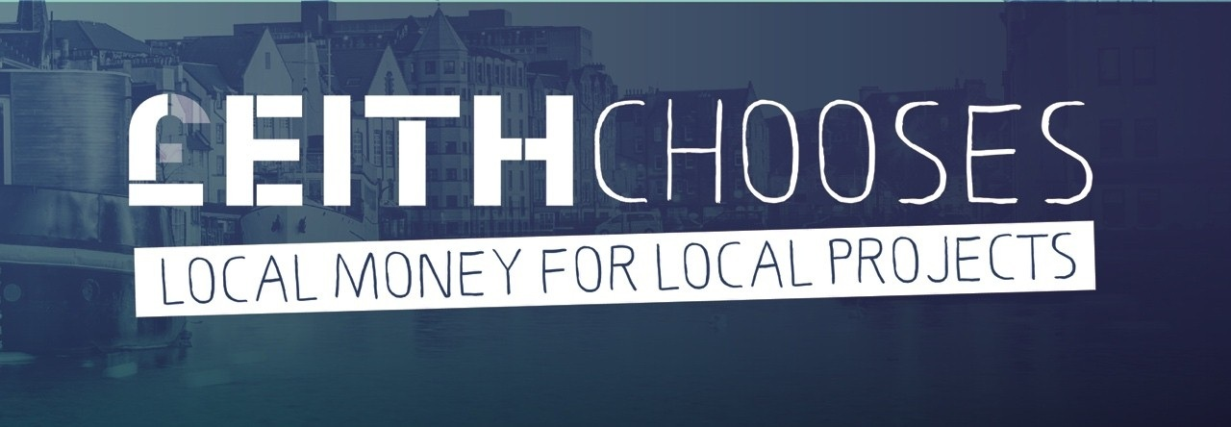
APPLICATION FORM
2019 – 2020

Application form – awards of up to £5,000

Privacy notice
Your organisation’s name, main contact person and website details will be made available to the public.
We will keep other personal information that you give us confidentially.
We will only use it for the £eith Chooses 2019-2020 participatory budgeting initiative.
We will not pass it on to anyone.
Any information that you give us will be stored for 2 years and then destroyed. Thank you.
Ref no. (Office Use Only) ________________

We need the following information to consider your application
Organisation name:
Contact address and postcode:

Main contact name & position:
Telephone number: | Website address:
Email address:
Please summarise your organisation’s main aims and activities. (maximum 50 words):

Addressing inequalities – your project
£eith Chooses invites bids for funding for local community projects, using funding from the City of Edinburgh Council’s Community Grants Fund. This is for small, one-off projects that meet urgent needs and progress local priorities.
Your project must clearly fit with fighting hunger and/or loneliness:
- Fighting hunger, e.g.
system or network to signal food emergency and/or provide information about help with food; cooking together, sharing food, educating about food and/or cooking; providing or (re) distributing food to people suffering from food inequality.
- Fighting loneliness, e.g.
systems/networks to identify people at risk of or actually suffering social isolation; activities to bring people together and with particular emphasis on supporting children, older people, disabled people, homeless people, vulnerable families or single parents, refugees, domestic abuse victims, people from minorities.

Now please outline your project in 100 words at most. Tell us how your project matches the theme, what activities will take place, how the grant money will be spent, and what the expected outcomes are. Please say who will benefit from your project.

We will copy and paste this description exactly when presenting your project information online for voters to read. Please remember that how clear your project description is will affect whether or not voters understand your project and vote for you.
Where will your proposed project be based?

What postcodes are covered by your proposed project?

Projects must be completed within twelve months, i.e. by March 2021. Please state your proposed start and finish dates:
Start date ___________________________ Finish date___________________________

Equality and diversity
What proactive efforts will you make to involve and benefit people from minority groups, particularly (but not exclusively) ethnic minority groups/communities?

You will be required to specifically document this.
How many people (roughly) from the Leith area will benefit from your proposal altogether?

What proportion of these (approximately) will be from ethnic minority communities?

What other minority groups will you include/target?

How will your proposal meet the needs of these groups: people with disabilities; faith communities, older people; lesbian, gay, bisexual or transgender (LGBTQ) people?

Partnership working
Have you consulted colleagues and/or other partners in relation to your proposal? If so, who?

Are other organisations involved in your proposal? If so, which?

Have you obtained consents, permissions or insurance necessary to carry out your proposal? (We may ask you to provide evidence of this.)
yes no not yet not necessary

Constitution and accounts
Does your organisation have a constitution? (Please note that only constituted organisations or groups under the banner of a constituted organisation may apply for £eith Chooses 2019–2020 funds.)
yes no
Please enclose the following documents with this application:
- Constitution, or Memorandum and Articles of Association, Trust Deeds of your organisation
- Most recent annual (audited) accounts. Where your organisation is newly constituted, the most recent bank statement will suffice.
- Quotations (for equipment, machinery or services costing over £300)

Bank account
Please give the details of the bank account this grant would be paid into if successful. This should be the same as your organisation’s name.
Name of bank:
Bank address:

Account name:

Bank sort code:
Account number:

If you have any problems completing this form, please contact Caroline Lamond: phone 0131 469 3507,
email caroline.lamond@edinburgh.gov.uk.

Project financial information
Project costs
Please list each item of expenditure for this project, showing how calculated, and enclose estimates or other evidence of costs, including in kind.
If there is a specific element(s) of this you are requesting from LeithChooses, please state this clearly.
Total expenditure
Project income
If your project costs more than requested from us, please list the source of any match funding or in-kind funding for this project, or if income from charges is anticipated. Please show evidence that such funding is secured and that you can complete the project.
Total income from other sources:
Amount requested from LeithChooses:

Declaration
Your application must be signed by two recognised representatives of your organisation.
By signing this form, you and your organisation declare that:
- You have read and will comply with all funding conditions;
- To the best of your knowledge, that the information contained in this application and any accompanying attachments is accurate.
Signature  Name  Date  Position | Signature  Name  Date  Position

Please send this completed form to:
Caroline Lamond
East Neighbourhood Centre
101 Niddrie Mains Road
Edinburgh
EH16 4DS
email caroline.lamond@edinburgh.gov.uk
Remember to include/send
- a copy of your group’s constitution
- details of your group’s bank account
- quotes for any items to be bought that cost £300 or more
- a good quality .jpg or .png image: your group’s logo,
a relevant photo or however you wish your project to be represented visually.

